**“Design and Manufacturing of Seat-Belt Assisted Hand Brake Release”**

**Mr. Mohit Raina**,**Mr. Nikhil Khairkar** ,**Mr. Siddharth Kakade** ,**Mr. Shubham Pawar, Mr.S.P.Velapure**

Department of Mechanical Engineering **Sinhgad Institute of Technology & Science,Narhe,Pune-41**

Abstract-Hand brake is one of the most important components in vehicles. In general, the hand brake is operated manually. In our project we are developing hand brake when Seat belt is not acquired off for safety purpose. Major causes of death in road accidents are carelessness in safety while driving. Hence wearing seat belts might have reduced serious crash related injuries and saved life. Hence "Driver Assistive Safety System" (DASS) comprises of techniques which inculcate the mandatory safety precautions via hand brake. This project describes safety system which ensures that the driver and co-passenger wear safety seat belt while driving a car. The driver assistive safety system works on 'HAND BRAKE REALESE" concept.

I. INTRODUCTION

The most important part in the automobile is the handbrake which is also. known as a latching brake. It is used generally when the automobile is parked, thus the alternative name that is parking brakes is used to keep the car stationary also called as automobile e-brakes. The most common used of a parking brake is to keep the vehicle motionless when it is parked. The main function of brake system is to decelerate the vehicle, to maintain vehicles speed during downhill operation and finally to park the vehicle stationary either on a flat or slope road condition. In cars the hand brake is a latching brake usually used to keep the car stationary. Automobiles e-brakes usually consist of a cable directly connected to a brake mechanism on one end and to some type of mechanism that can be actuated by the driver on the other end of mechanism is often a hand operated lever, on the floor on either side of the driver, a pull handle located below and near the steering wheel column, or a pedal located far apart from the other pedals. In road vehicles the parking brake also called as hand brake, emergency brake or e-brake is used to keep the vehicle stationary. In normal vehicles a hand brake is consist of a cable connected to two-wheel brakes at one end and the other end to a pulling mechanism which is operated by human with hands.

**Importance of Seat Belt in Cars.**

Seat belt implemented in cars to ensure drivers safety. The increase in loss of life in accidents due to driver's negligence to wear seat belt though it is strictly enforced by government rules. The aim of our project is to make seat belt wearing compulsory for vehicle movement.

The main purpose of this project is to ensure drivers safety through a modified handbrake in car. A handbrake is an additional braking mechanism installed on all commercial vehicles that's completely separate from foot pedal operated. In cars the parking brake, also called hand brake, usually used to keep the vehicle stationary. Most commonly used to prevent the vehicle from rolling when it is parked. Automobile hand brakes consist of a cable directly connected to the brake mechanism on one end and to a lever at the driver's position. Using your handbrake to stop a moving car can damage the brake system.

In this project we have designed the mechanism which is used to operate hand brake using seat belt assist. While removing the hand brake this mechanism or system ensures that seat belt is plugged in by the driver. As the driver acquire seat belt the hand bake gets free and can be removed.

**Parking Brake**

In road vehicles the parking brake, also known as a hand brake or emergency brake (e-brake), is a mechanism used to keep the vehicle securely motionless when parked. Historically, it was also used to help perform an emergency stop. Parking brakes often consist of a cable connected to two wheel brakes, which is then connected to a pulling mechanism. In most vehicles, the parking brake operates only on the rear wheels, which have reduced traction while braking. The mechanism may be a hand-operated lever, a straight pull handle located near the steering column or a foot-operated pedal located with the other pedals.

**How It Works**

The car handbrake is designed to bypass the hydraulic braking system in the event of a failure. When you apply the emergency brake, the metallic cable it is connected to passes through an intermediate lever enhancing the power of the pulling. Then comes an equalizer that splits that power evenly between the brakes;

In most vehicles the disc or drum brakes have a connection to a mechanical lever. If it is the disc brake the existing caliper piston is likely to have a connection to an additional lever and corkscrew. When you pull the brake on the lever makes the corkscrew to force against the piston. If it is drum brake the metallic cable has a direct attachment to the lever on the brake shoes. As we know how handbrake works and its importance in the event of a hydraulic brake failure. But don't apply it when the foot brake is still operational. It will disrupt the brake's balance and the vehicle may lose control.

**Emergency Braking system**

Although sometimes known as an emergency brake, using it in any emergency where the footbrake is still operational is likely to badly upset the brake balance of the car and vastly increase the likelihood of loss of control of the vehicle, for example by initiating a rear-wheel skid. Additionally, the stopping force provided by using the hand-brake is small and would not significantly aid in stopping the vehicle. The parking brake operates mostly on the rear wheels, which have reduced traction while braking. But in some cases, parking brake operates on front wheel, as done in most Citroens manufactured since the end of World War II. The hand brake is instead intended for use in case of mechanical failure where the regular footbrake is inoperable or compromised. Modern brake systems are typically very reliable and equipped with dual-circuit hydraulics and low-brake-fluid sensor systems, meaning the handbrake are rarely used to stop a moving vehicle.

**Demand for electronic**

Hence, there is great demand for an electronic applied mechanism, with automation for actuation of the parking brake. It should also save space, reduce overall weight, complication in linkages, less mechanical parts prone to wear and tear, good responsive technique, high durability, very less or no involvement of human, easy to repair and economic. The EMPB (Electro-Mechanical Parking Brake) system helps to enhance driving safety and comfort and provides greater freedom in interior design and packaging. EMPB (Electro-Mechanical Parking Brake) eliminates the need for a parking brake lever or pedal and improves vehicle styling, space management and crashworthiness.

The EMPB (Electro-Mechanical Parking Brake) system is composed of one electro-mechanical actuator integrated into the disc brake caliper and a controller with redundant connections to the power supply, which is controlled inside the vehicle's cabin by a simple rocker switch. EPB is electronically controlled and features can be designed easily through software giving an enhanced level of freed for driver comfort and safety functionality.

Although sometimes known as an emergency brake, using it in any emergency where the footbrake is still operational is likely to badly upset the brake balance of the car and vastly increase the likelihood of loss of control of the vehicle, for example by initiating a rear-wheel skid. Additionally, the stopping force provided by using the handbrake instead of or in addition to the footbrake is usually small and would not significantly aid in stopping the vehicle, again because it usually operates on the rear wheels; they suffer reduced traction compared to the front wheels while braking. The emergency brake is instead intended for use in case of mechanical failure where the regular footbrake is inoperable or compromised, hopefully with opportunity to apply the brake in a controlled manner to bring the vehicle to a safe, if gentle halt before seeking service assistance. Modern brake systems are typically very reliable and engineered with fail safe (e.g. dual-circuit hydraulics) and failure-warning (e.g. low brake fluid sensor) systems, meaning the handbrake is no longer often called on for its original purpose.

The most common use for an automobile emergency brake is to keep the vehicle motionless when it is parked, thus the alternative name, parking brake. Car emergency brakes have a ratchet locking mechanism that will keep them engaged until a release button is pressed. On vehicles with automatic transmissions, this is usually used in concern with a parking pawl in the transmission. Automotive safety experts recommend the use of both systems to immobilize a parked car and the use of both systems is required by law in some jurisdictions, yet many individuals use only the "Park" position on the automatic transmission and not the parking brake. It is similar to manual transmission cars; these are recommended always to be left with the handbrake engaged, in concert with their lowest gear (usually either first or reverse). The use of both systems is also required by law in some jurisdictions. However, when parking on level ground, many people either only engage the handbrake (gear lever in neutral) or only select a gear (handbrake released).

**Electromagnetic brakes**

Electromagnetic brakes (also called electro-mechanical brakes or EM brakes) slow or stop motion using electromagnetic force to apply mechanical resistance (friction). They were originally called "electro-mechanical brakes," but over the years the name changed to "electromagnetic brakes", referring to their actuation method.

In locomotives, a mechanical linkage transmits torque to an electromagnetic braking component.

Electric motors in industrial and robotic applications also employ electromagnetic brakes.

**Auto-Transmission system**

Some cars with automatic transmissions are fitted with automatically releasing parking brakes. Later models require the foot brake to be depressed before the car's transmission can be moved from park. When reverse or drive is selected, the parking brake automatically releases. Earlier models would release the parking brake when the gear selector was placed in a forward or reverse gear without requiring any input on the brake pedal at all. These earlier automatic release systems were a safety hazard. Since there would be no protection against accidentally knocking the transmission into gear

In cars with rear drum brakes, the parking brake cable usually actuates these drums mechanically with much less force than is available through the hydraulic system.

In cars with rear disc brakes, the parking brake either actuates the disc calliper’s (again, with much less force) or a small drum brake housed within the hub assembly (the inner circumference of the disc is often used instead of a separate drum).

Hudson automobiles used an unusual hybrid hydraulic-mechanical dual-brake system which operated the rear brakes through the otherwise conventional mechanical emergency-brake system when a failure of the hydraulic system allowed the pedal to travel beyond its normal limit. • A number of production vehicles, light and medium duty trucks, and motor homes have been made with a separate drum brake on the transmission output shaft; called a driveline parking brake. This has an advantage of being completely independent of other braking systems. This is effective as long as

The drive train is intact-propeller shaft, differential, and axle shafts. In many vehicles, this type of parking brake is operated by either a foot pedal or a hydraulic cylinder controlled by the transmission gear selector, or by both.

The EMPB system is a semi-automated system in which motor rotates as per the signals from an ECU. Considering engine ignition is on and vehicle is at rest, as soon as the engine is turned off, microcontroller senses this and sends actuating signal to motor relay. As the motor starts to rotate (Anticlockwise), the rotary speed of motor is reduced, hence torque is increased using gear trains and its output is supplied to lead screw which rotates in a nut, in turn converts rotary motion to linear motion, hence pushing the brake pad against the disc and parking brake is hence applied. In other hand, when engine is started, the microcontroller senses this and actuates the motor to rotate in opposite direction (Clockwise), hence releasing the parking brake. The design is made so that it can be applied to 350 kg vehicle. The EMPB system works satisfactorily on ignition conditions. The HOLD and release functions also works in an acceptable manner. It is seen that the average response time of the EMPB system is 600-700 ms.

# **II Problem Statement**

“Not wearing a seat belt causes the most devastating injuries today. Seatbelts save lives. Years of practice have neglected driving safety. Negligence causes most road deaths and tragedies. Use seatbelts or helmets to survive an accident. Seatbelts protect car drivers. Despite rules, more deaths from drivers not using seat belts. Our project mandates seatbelt use.”

**III OBJECTIVE**

To ensure the motorist's safety; the seat belt and brakes are both disengaged at the same time. The price is reasonable; to develop a habit of wearing a seat belt; Create the proposed system's 3D modal in CATIA V5 software.

To perform analytical calculations on the components used? Conduct a market survey to determine component availability and specifications at the lowest cost. To get the same result as the original. It puts the built-in modal weather to the test. Reduce the cost of braking by using a correct mechanism for the demo modal.

**VI. Research Methodology**

We started the work of this project with literature survey. We gathered many research papers which are relevant to this topic. After going through many research papers, we learnt how can we use selt-belt assistance to release brake system and ensure safety for automobile.

The main aim of our project is to prevent accidents and ensure safety. We first started designing the project in CATIA V5. After the designing process we ran some tests through animation. After that we selected the materials and components based on dimensions and proper parameters. We started selecting the proper wheel size of an automobile, according to which we designed a shaft that will lock and un-lock the wheel and designed various components such as links and brake locking mechanism. Then we designed the frame work to support the wheel as well as other components. Then we selected the proper electric units like Wiper-motor, Arduino, Sonar senor, then we programmed the Arduino.

After that according to the design we manufactured the components and assembled them together. The experimental observations, testing and calculations were done and then the result was concluded.

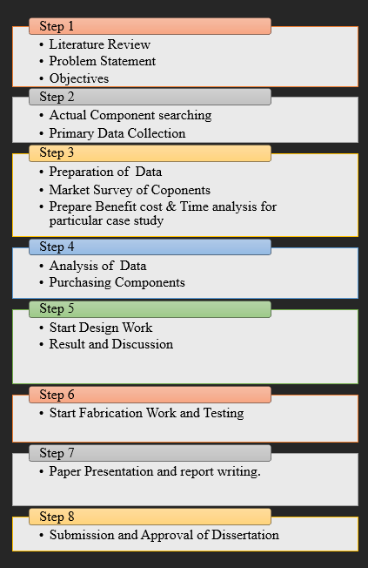

**Figure.1: Methodology Flow**

**VI TESTING**

Testing

The testing process started after completing the fabrication process, as soon as we put the seat belt on, the sonar sensor detects the seat belt and sends the information to Arduino UNO, which then makes the wiper motor rotate clockwise and releases the brake.

And when we take off the seat belt the sensor detects the seat belt was detached and it transferred the information to Arduino Uno and brakes got engaged. Hence the working of our project was successful

We tested the sonar sensor by performing an experiment of placing an object in front of it to check the results. Then we tested the braking mechanism by rotating the wheel manually and checked how the brakes stop the wheel. We tested the frame work by putting load on it to see if it can sustains the weight of our project.

From our project we ensure that driver compulsorily wear seat belt while driving if he tries to run whithout the seat belt the brakes could not be disengaged by this the driver safety will be ensured.

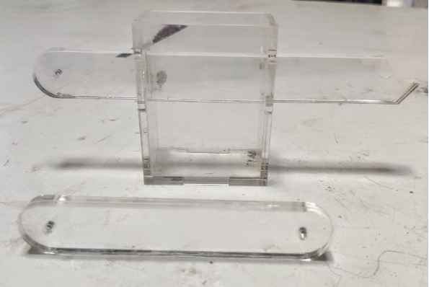

##### 

##### 

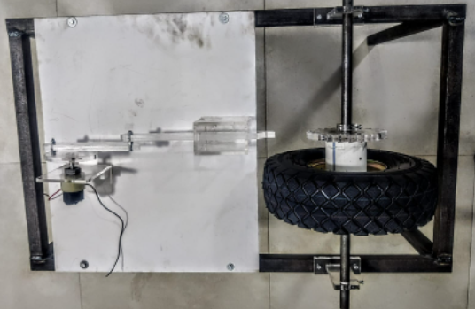



##### **CONCLUSION**

We developed and created our modal in software, as you can see in the Design section. We were able to effectively calculate the components required to create our project, such as their failure and forces at a certain moment, by assuming certain values. We will purchase the components required to execute the project based on the findings of the market study. Finally, we'll put the prototype modal together and test it to see if it works as expected.

**ACKNOWLEDGMENT**

We express our sincere thanks to Project Guide **Mr.S.P.Velapure** for his continuous support. We also thankful to our Head of Department of Mechanical Engineering **Dr. K.R Jagtap** For support

##### **REFERENCES**

1. "WEARING OF SEATBELT IS MANDATORY FOR IGNITION OF ENGINE" Prof. Hemal Patel, Chauhan Abhijeetsinh, Badreshiya Deepak, Patel Harsh
2. "DESIGN AND FABRICATION OF AUTOMATIC HANDBRAKE USING PNEUMATIC SYSTEM" Thorat Ajit, Kokane Sujit, Kokane Tushar, Jadhav Nilesh, Temgire Sanket
3. "AUTOMATIC HAND BRAKE SYSTEM" Akash D. Singh Siddhesh P Rahate, Amit V. Pawaskar, Ravindra K. Ambekar
4. "DESIGN OF SEATBELT ACTIVATED HANDBRAKE SYSTEM IN CARS" Naveen kumar., Lokesh raj., Ramerow jacob., Santhosh., Ravi prasad.p.s
5. "A REVIEW ON SAFETY PARKING BRAKE ARRANGEMENT ACTUATED BY SEATBELT. "Salvekar Mandar Sambherao Shivaji. Patil Vishal, Pimpaliskar Shubham
6. "MODIFICATION AND IMPLEMENTATION OF AUTOMATIC HAND BRAKE SYSTEM USING SENSOR" Rohit Khubalkar, Saurav Kumar, Kishen Jadhav, Vaibhav Regundawar, Aniket Phatangare